**FIrst Approach:**

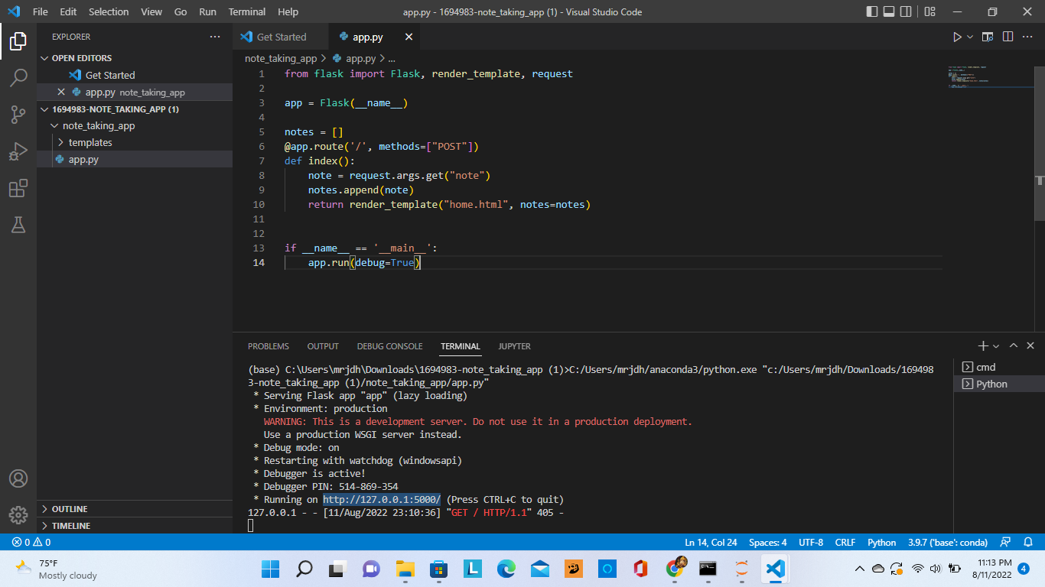

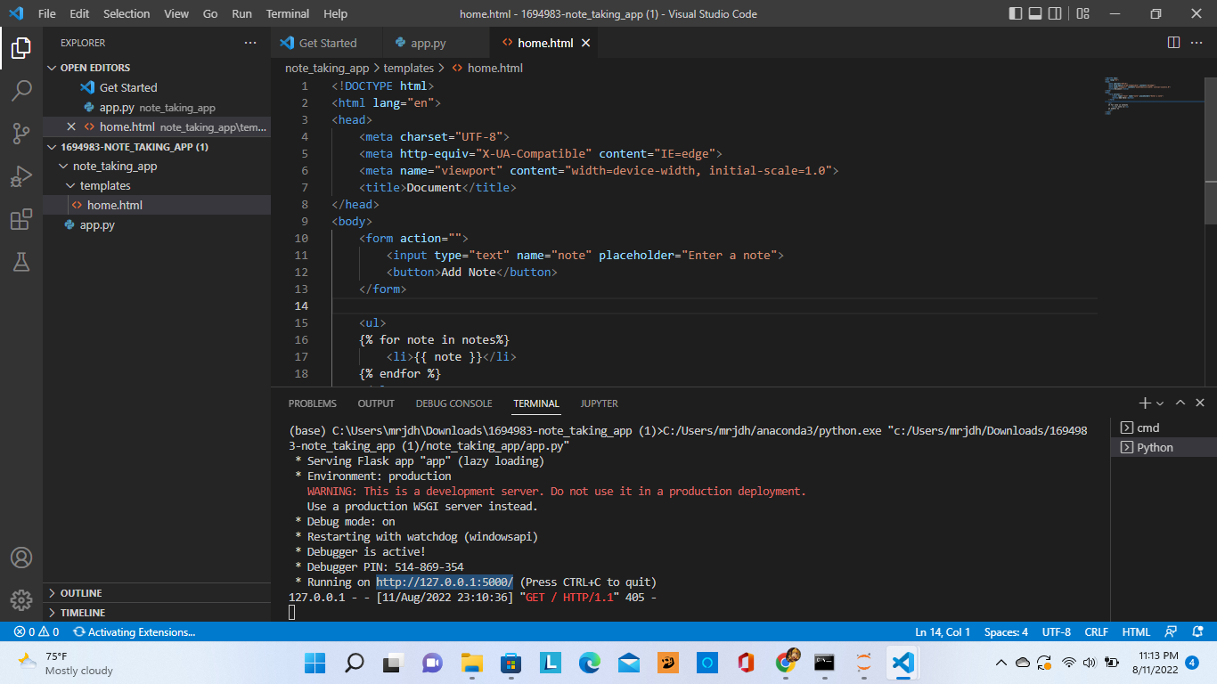

When I run the above code I got the below error:

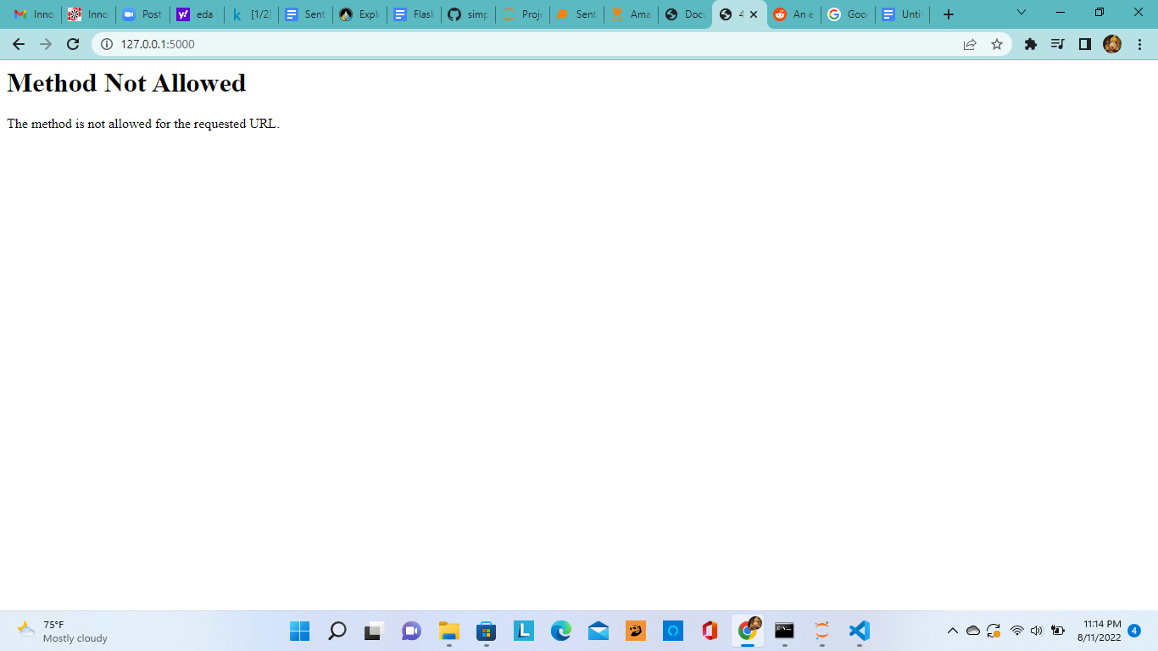

request.args.get("note")

flask.Request.args returns the part in the URL after the question mark.

And the method is by default GET.

WIth the method GET we will get all the information which was entered through form in the URL after the question mark.

But if you see, the .py file

@app.route('/', methods=["POST"])

It is taking the method as POST but not GET.

So I have changed the code as

@app.route('/', methods=['GET', 'POST'])

So that it will retrieve all the information passed through the form.

By default the method is GET so there is no need to change the method in form.

Final output:







**Second Approach:**

flask.Request.args returns the part in the URL after the question mark.

flask.Request.form returns the data which was entered through the form.

So if we change the method to POST we need to use request.form in py file.

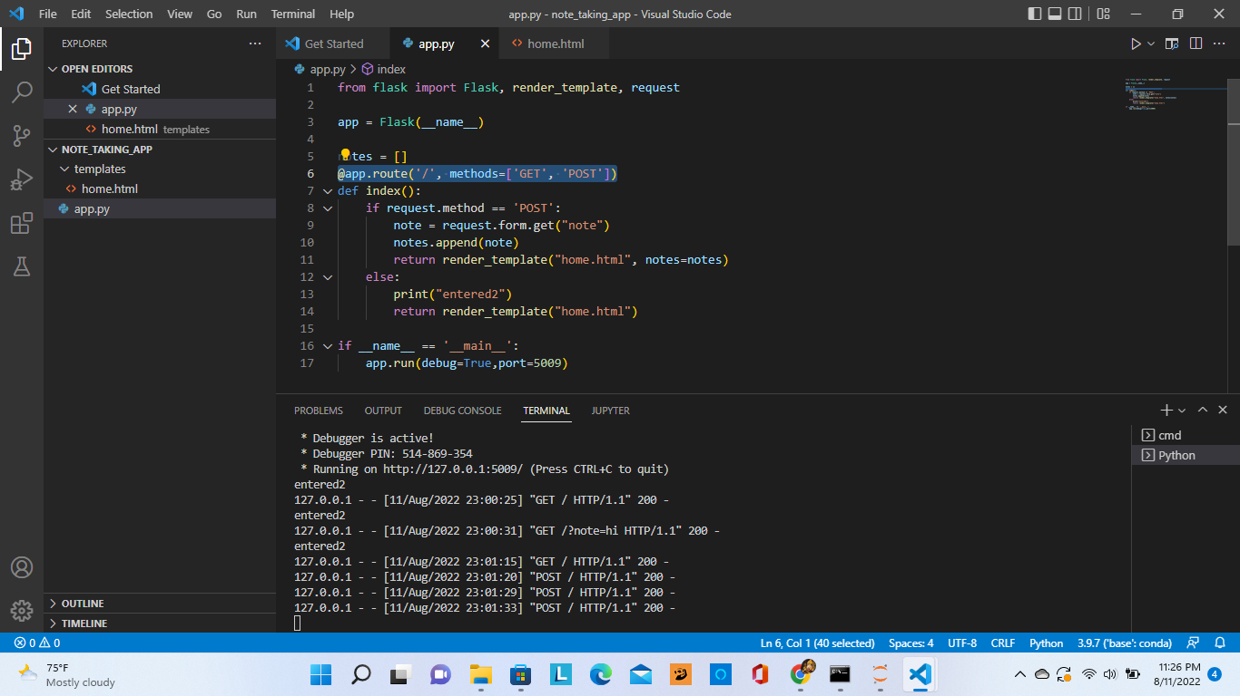

And in form we have to use method=”POST”

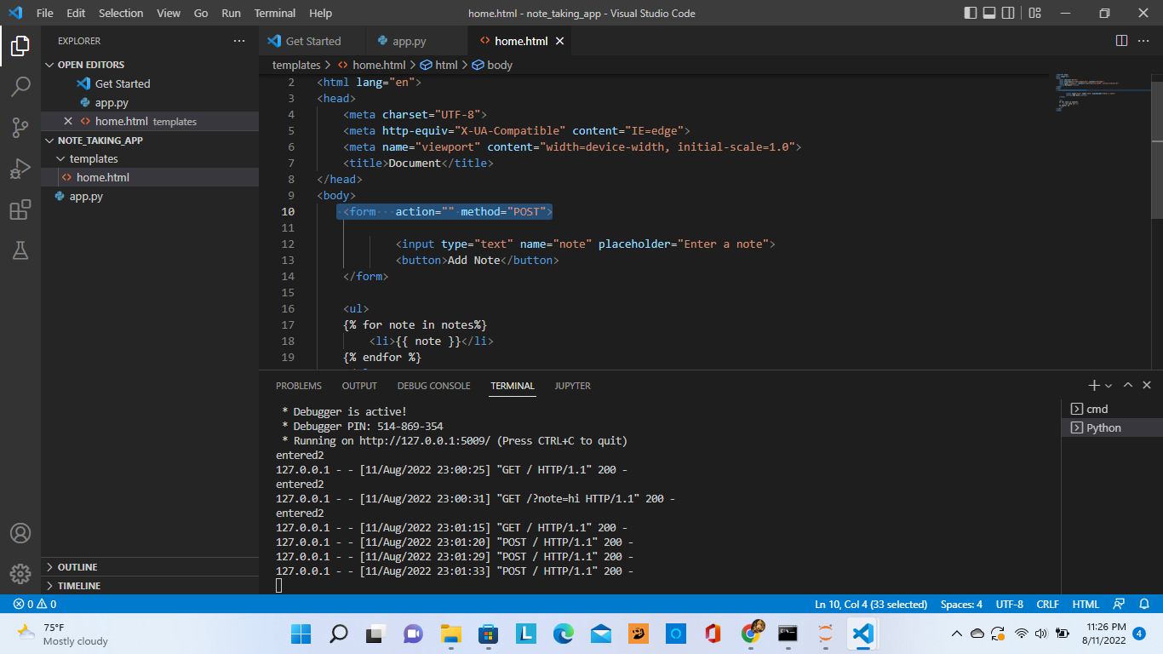

The final output is:

